Planning and Assessment Procedure
Associated National Quality Standards | Education and Care Services National Law or Regulation |  | Associated department policy, procedure or guideline
1.1  1.2  1.3 | Regulation 73  Regulation 74  Regulation 75  Regulation 76  Regulation 254  National Law S. 323  National Law S.168 |  | Leading and Operating Department Preschool Guidelines=
Pre-reading and reference documents
Belonging, Being & Becoming: The Early Years Learning Framework for Australia
National Quality Standards: Quality area 1
8 ways of aboriginal learning
The Early Years Learning framework modules
An integrated approach to planning and learning
Djanenjam Preschool Philosophy
Djanenjam Preschool Daily Rhythm
The EYLF planning cycle at Djanenjam Preschool
Staff roles and responsibilities
School principal | The principal as Nominated Supervisor, Educational Leader and Responsible Person holds primary responsibility for the preschool.  The principal is responsible for ensuring:  - the preschool is compliant with legislative standards related to this procedure at all times  - all staff involved in the preschool are familiar with and implement this procedure  - all procedures are current and reviewed as part of a continuous cycle of self- assessment.
Preschool supervisor | The preschool supervisor supports the principal in their role and is responsible for leading the review of this procedure through a process of self-assessment and critical reflection.
Preschool educators | The preschool educators are responsible for working with leadership to ensure:  - all staff in the preschool and daily practices comply with this procedure  - storing this procedure in the preschool, and making it accessible to all staff, families, visitors and volunteers  - being actively involved in the review of this procedure, as required, or at least annually  - ensuring the details of this procedure’s review are documented.
Procedure
At Djanenjam Preschool, Educators engage in an ongoing cycle of learning and assessment that is based on the Early Years Learning Framework (EYLF) and National Quality Standards (NQS) and exceeds the requirements set out by the national law and regulations.
All children are planned both as a group and individually, ensuring their unique needs, skills and interests are forefront of planning. Family and community perspectives are included wherever possible through our initial parent partnership meetings, during check-in meetings and through ongoing verbal feedback, comments, and messages.
Djanenjam Preschools uses the application “Storypark” to plan, document and communicate at each stage of the planning cycle, ensuing families are always informed and have access to their child’s learning and educational program. Educators engage in critical reflection both individually and as a team to ensure planning and assessment is relevant and meets the needs of all children. Planning is flexible, and provocations are play-based allowing for inquiry-based child-lead learning. Our daily rhythm and philosophy provide a gentle platform and guide.
Although specifying exact numbers of learning stories or observations is not our focus, it is expected that all children will have at least 3 completed cycles of planning by the end of the year. Educators are encouraged to pursue quality, over quantity, flexibly allowing the child to lead their own learning journey.
The components of the Planning and Assessment cycle include:
Observing children in play and gathering information | - Educators observe interests, and spontaneous inquiry, and document this.  - Observations are documented through anecdotal notes, photos, videos, drawings, or audio. This may be on designated observation note paper or using the notes or story feature on storypark.  - Educators draw on existing learning journeys, the child’s own voice, prior notes, and parent communication to provide context.
Questioning and evaluating | - Educators consider existing strengths, needs and interests and how these might be extended.  - Educators consult with the EYLF to assess what learning has taken place.  - Parent voice is considered based on information gathered during parent partnerships, conversation, or Storypark comment.  - Information is documented as part of the learning journey or as its own brief learning story on Storypark and within the program as needed.
Planning and developing learning intentions | - Learning intention(s) are identified and documented based on the EYLF and the child’s developmental strengths, interests, and goals.  - Follow-on experiences occur either (spontaneously) in the moment or planned for a future date and are documented in the weekly program.  - Parent perspectives are sought through the storypark app or through conversation.  - Intentions align with the EYLF outcomes, principles, and practices and 8 ways of aboriginal learning, where appropriate.
Implement | - Educators implement meaningful experiences that promote learning and growth.  - Educators support learning using a balance of intentional teaching and inquiry-based pedagogy that considers the strengths, needs and interests of the individual child. For instance, questioning is used to scaffold higher order learning.  - Educator’s document this learning experience through pictures and anecdotal notes to refer to when evaluating the experience.
Document and Reflect | - Educators engage in reflective practice, considering “what learning took place?”, as well as reflecting on the success or challenges found within their own teaching practice.  - Learning is evaluated and linked to the Early Years Learning Framework (EYLF), developmental milestones and/or theorists where relevant.  - The learning journey is documented anecdotally throughout the cycle and may include photos, audio, video, or handwritten notes. This data is consolidated into a learning story.  - Parents are valued as the child’s first teacher and encouraged to comment and engage with their child’s learning.  - Learning stories are shared with families using the storypark app and a copy is added to the child’s learning journal for parents to view and provide feedback in the community room.  - Future goals and possibilities for learning are documented and the ongoing learning and assessment cycle continues.
The Planning cycle at Djanenjam Preschool 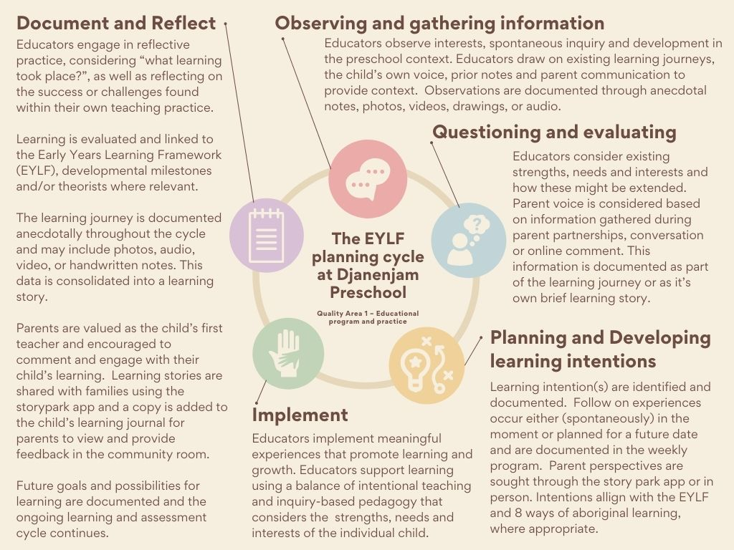 |  |  |  | Philosophy
Daily Rhythm  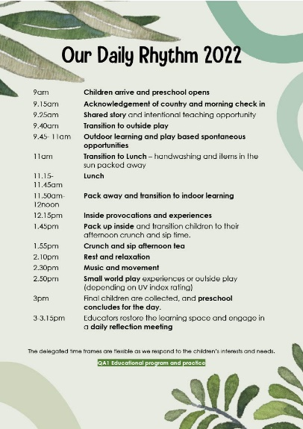 |  | Team Reflection  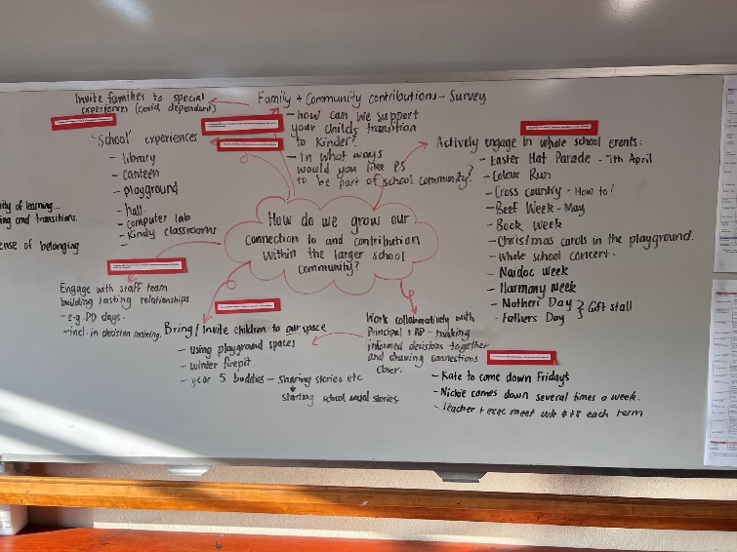
Example weekly plan and program reflection
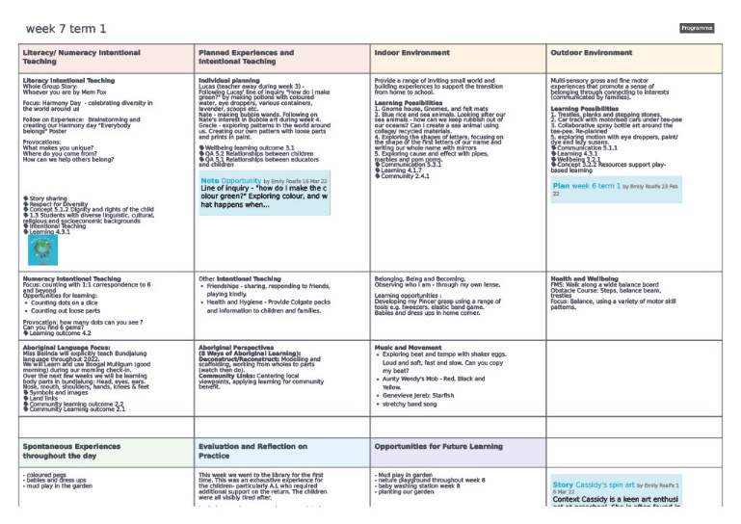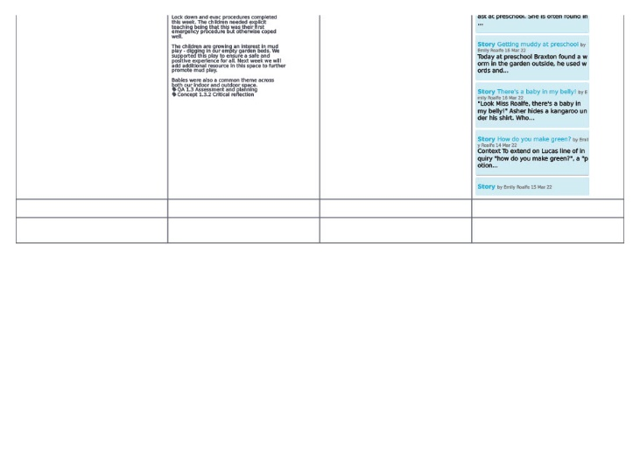
Example Observation and learning story
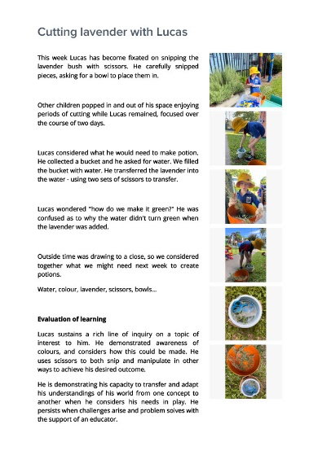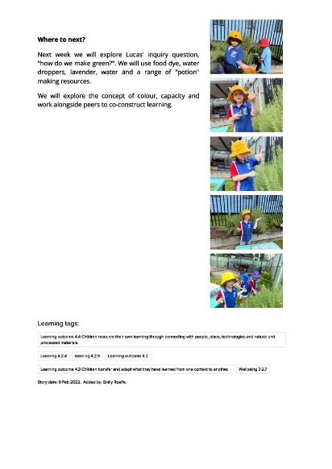
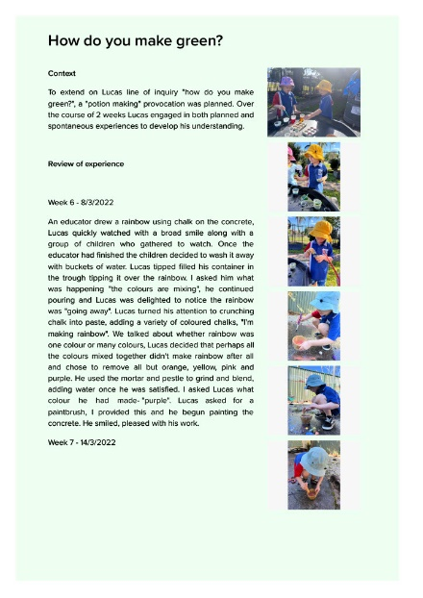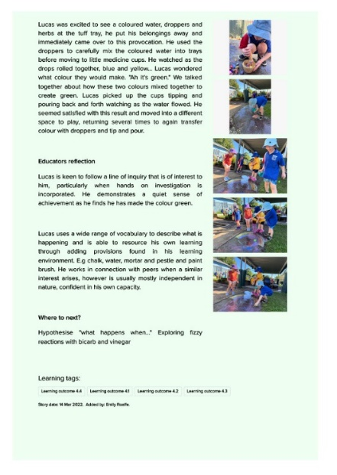

Record of procedure’s review
Date of review and who was involved
Emily Roalfe, Trudie Charnock, staff team and families 25/3/2022
Key changes made and reason/s why
New Localised procedure – no preexisting planning and assessment procedure.
Record of communication of significant changes to relevant stakeholders
Communicated with core staff 25/3/2022 with printed policy for families to review in detail.
Copy and paste a new table to record each occasion the procedure is reviewed.

