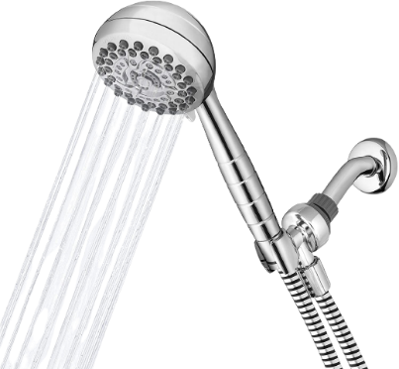
Showering procedures at
Djanenjam Preschool

Preparation
- Notify other educators.
- Reassure the child and let them know you will be going to the laundry and change room for a shower.
- Collect child’s bag/ spare clothing and 2 plastic bags.
- Source the Hazardous-soiled materials tub from under the change table.
- Place floor towel on floor for child to stand on.

Changing and showering
- Dispose of excess fecal matter into the toilet.
- Place clothing into a bag and put into bucket under laundry sink. Soiled clothing to remain in bucket until child’s departure.
- Use baby wipes to wipe the child clean and place wipes into plastic bag.
- Assist child into shower and wash the child standing in the shower. Place floor towel into hazardous materials tub.
- Dispose of gloves into bag with baby wipes, seal the bag and put into nappy bin in laundry.
- Assist child out of the shower and onto a clean floor towel. Dry the child.
- Redress child, assisting if required. Child to return to play with other educators if well. If unwell child should be supervised in a quiet space away from other children until collection.

Cleaning
- Reapply new gloves, spray shower with disinfectant, wipe with red cloth and rinse. Place red cloth in hazardous materials tub.
- Wash used towels in washing machine – on their own to avoid cross contamination. This step may need to be repeated if extremely soiled.
- Remove gloves and wash hands

Communicating and documenting
- Document on toileting and change log with time, date and description.
- Call family if necessary or notify family on departure- sending soiled clothes home.

Refresh
- Using gloves, wash Hazardous-soiled materials tub with warm soapy water and dry. Remove gloves and place in bin.
- Replace towels and plastic bags and return tub to designated location under the change table.

Stand-up nappy/pull-up change procedures at Djanenjam Preschool
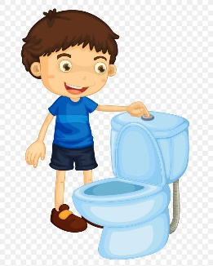
Use physical supports as required including fixed hand rail, toilet frame surround and or low chair for educator to sit on during the process:

Preparation
- Wash Hands.
- Put on gloves.
Changing
- Encourage child to pull down their pants (assist if required) and remove nappy/pull ups and place in nappy bin.
- Remove any soiled or wet clothing.
- Encourage child to wipe their own bottom, if assistance is required educator is to wear gloves.
- Remove gloves peeling them back from the wrist and turning them inside out as they are removed. Place gloves in bin.
- Place clean nappy/pull-ups on child; encourage child to participate in dressing (assist if needed).
Cleaning
- Wash and dry child’s hands
- Place on gloves and clean the toileting area if required. Remove gloves and place in bin.
- Wash your hands
Documenting
- Document on toileting and change log with time, date and description.

General toileting procedures
- Educators discuss children’s individual needs with families to ensure practices are reflective of the home environment and are culturally sensitive
- Toileting Is embedded within our daily rhythm, children are given explicit opportunity to use the toilet when they wash their hands at 9am, 11am, 2pm and 3pm. Educators provide a number of additional reminders and children have access to toilets at all times throughout the day.
- Children are supported and encouraged to be independent in their toileting. Privacy screens are provided between each toilet and children are given space and opportunity to remain independent.
- Toileting accidents are treated with sensitivity and the child supported while maintaining the child’s dignity during the changing process.
- Children are encouraged to wipe their own bottoms. If they are unable to do so, an educator will assist wearing gloves.
- Children will be guided to follow the process of wiping front to back, flushing the toilet, washing and drying hands.
- Bathrooms are monitored routinely to maintain hygiene and cleanliness.
- Supervision is maintained in the bathrooms at all times.
- A toileting log is kept for children who wear nappies/pull-ups or have soiling accidents.
- Educators keep nappy change areas fully stocked with all required materials, at all times. Educators are responsible for maintaining the supplies to meet the needs of individual children. Supplies will be readily accessible to staff to ensure efficiency and the health and safety of each child.
- Nappy change procedure and visual reminders are available in the changing area to ensure all staff are aware and have access to current procedures.

